Thanks guys:

Please consider the following:

- You have to be clear on the area that will be testing (if needed describe it or add an image)
- 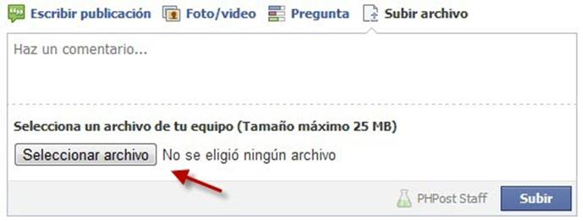
- 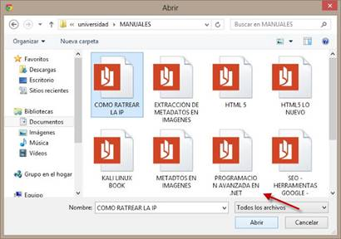

If you have any questions or concerns please feel free to let me know
Thanks
Veronica

Names: Ariel Wagner Rojas
Miguel Terceros Caballero
Program: QADEV04
Function: Publish a file on wall news the Facebook.
1.
Title: | Verify that the do clicking the examine button, should open the file browser.
Description: | Clicking on the Browse button should open the file browser the system to find the file to upload .
Steps: | - Click on the examine button.  - View that be open the file browser.
Expected Results: | It should open the file browser.

2.
Title: | Verify that the do clicking the examine button does not open the file browser.  It is not clear for me what do you want to test here
Description: | When we click on the examine button does not should open a file browser and should to display an error message.
Steps: | - Click on the examine button.  - View that does not open the file browser.  - Error display.
Expected Results: | Display the message:  “There was an error opening the file browser”. “is this a real functionality?” please provide the correct steps so I can see the message

3.
Title: | Verify that the file type upload this allowed.
Description: | Once the file selected by the user it should belong to the list of files allowed for the page Facebook and should display an icon validate of green color.
Steps: | - Search the file.  - Select the file.  - Click in the insert button.  - Verify file type.  - Show icon validation.
Expected Results: | Show the icon validation in green color.

4.
Title: | Verify that the file type that be upload does not this allowed .
Description: | If file that is loading does not this allowed, should display an error icon of red color.
Steps: | - Search the file.  - Select the file.  - Click in the insert button.  - Verify file type.  - Show icon error.
Expected Results: | Show an error icon red with the following message:  “The file type is not allowed.”

5.
Title: | Verify that the selected file has been published correctly.
Description: | When the file has been published it should be displayed on the wall of news.
Steps: | - See the news wall.  Steps are needed
Expected Results: | Displayed the file on the news wall.  Selected file is displayed on the news’ wall

Cecilia/Damian

Please consider my below suggestions and also send ME the answers to my questions

Thanks
Veronica

Facebook Upload Video High Level Test Cases

TITLE: | Verify that allow upload a video whose size don’t exceeds 1GB  Please answer below questions:  Let’s first think on What do you want to test? That the video can be uploaded? That the process is displayed?  Is this a Valid/Invalid scenario? Is this an equivalence class?  Is this a positive/negative TCs?  I would suggest to change the title to something like:  Verify that videos with less than 1GB can be uploaded.  Or  Every time that a video is uploaded “Processing video” message window is displayed.
DESCRIPTION: | Each time that a upload a video whose size don’t exceeds 1GB is downloaded, there should be a display a notify message of processing the video also can be seen the percentage loading at right window facebook.
STEPS: | - Click to the icon “photo/video” video in the wall  - Select the video in the computer files  - Click to the “Accept” button  More steps are needed in order to execute correctly the TC
EXPECTED RESULT: | A notify message: processing video, such as attached image should be displayed. (for the second title)  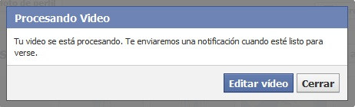
TITLE: | Verify that allow video to load don’t exceeds 20 minutes duration  I think that this is not a valid scenario, why do you think is a valid one? Please anwser
DESCRIPTION: | Each time upload a video whose duration don’t exceeds 20 minutes, should display a notify message of processing the video also can be seen the percentage loading at right window facebook.
STEPS: | - Click to the icon “photo/video” video in the wall  - Select the video in the computer files  - Click to the “Accept” button
EXPECTED RESULT: | A notify message: processing video, such as attached image

TITLE: | Verify that don’t allow upload a video whose size exceeds 1GB
DESCRIPTION: | Each time upload a video whose size exceeds 1GB, should display a notify message of exceeds allow size .
STEPS: | - Click to the icon “photo/video” video in the wall  - Select the video in the computer files  - Click to the “Accept” button
EXPECTED RESULT: | A notify message: the size video exceeds allowed which is that message?

TITLE: | Verify that don’t allow upload a video whose duration exceeds 20 min //same as above
DESCRIPTION: | Each time upload a video whose duration time exceeds 20 min, should display a notify message about exceeds allow duration.
STEPS: | - Click to the icon “photo/video” video in the wall  - Select the video in the computer files  - Click to the “Accept” button
EXPECTED RESULT: | A notify message: the duration time video exceeds allowed

TITLE: | Verify the video uploaded successfully display a confirmation window
DESCRIPTION: | When charging the selected video has been uploads successfully finished, a Notify message about the upload is complete is displayed.
STEPS: | - Click to the “Accept” button  - Wait a few minutes to the upload finished  - Check the notifications
EXPECTED RESULT: | A notify message: your video it’s processing, we will notify you when it finished and it’s posted.  Please enter the expected message

TITLE: | Verify that the video it’s posted in the account wall  This one is well written except for the steps
DESCRIPTION: | Each time that the confirmation notifies it’s displayed, the video posted should be displayed on the account wall.
STEPS: | - Check the notifications  - Check the account wall
EXPECTED RESULT: | The video posted in the account wall.

TITLE: | Verify that the uploaded processed video can be played.
DESCRIPTION: | Each time that clicked to the icon video, should open a reproduction window and play the video automatically
STEPS: | - Check the account wall  - Press the icon video post  - Wait for a reproduction window
EXPECTED RESULT: | The video playing.

TITLE: | Verify allow only video format allowed by facebook  I would suggest have something like:  An error message is displayed when a none allowed video format is selected.
DESCRIPTION: | Each time when try to upload a video to facebook, should only allow the following formats:  • asf (video de Windows Media), avi (video AVI), dat (video MPEG), divx (video DIVX), dv (video DV), f4v (video Flash), flv (video Flash), m2ts (video M2TS), m4v (video MPEG-4) , mkv (formato Matroska) , mod (video MOD) , mov (QuickTime Movie) , mp4 (video MPEG-4) , mpe (video MPEG) , mpeg (video MPEG) , mpeg4 (video MPEG-4) , mpg (video MPEG), mts (video AVCHD), nsv (video Nullsoft), ogm (formato multimedia Ogg), ogv (formato de video Ogg), qt (QuickTime Movie) , tod (video TOD), ts (MPEG Transport Stream), vob (video de DVD Video) , wmv (video de Windows Media)
STEPS: | - Click to the icon “photo/video” video in the wall  - Select the video in the computer files  - Click to the “Accept” button
EXPECTED RESULT: | A notify message: processing video, such as attached image  An error message Is displayed “…….”  Question for you? Is this a facebook functionality? I mean facebook does not allow some videos format?

Thanks Jorge/Ivan

I do not have any further observations except “filechooser”, maybe you can use something like “open file window”

Regards
Veronica

Functionality: publish an image on facebook web version

Title: Verify that the filechooser is opened when the “upload image” button is clicked
Description: the filechooser will be displayed when the upload image is clicked, it doesn’t matter the directory where this is displayed
Steps: 1. Stand at the facebook homepage
2. Click the upload image button (camera image)
Expected Result: the filechooser must be displayed
Title: verify that an image was loaded to publish
Description: when an image is selected from the filechooser and the open button has been clicked it should be displayed a progress bar while the image is being loaded to publish
Steps: 1. Stand at the facebook homepage
2. Click the upload image button (camera image)
3. In the filechooser opened select an jpg, png, gif or tiff image format
4. Click in the open button
Expected Result: the image loaded and visible ready to publish
Title: verify that another file formats cannot be loaded
Description: when the file selected from filechooser has not jpg, gif, png or tiff format and the open button has been clicked it should be displayed a progress bar loading and when this is about to finish an error message must be displayed
Steps: 1. Stand at the facebook homepage
2. Click the upload image button (camera image)
3. In the filechooser opened select any file distinct to jpg, png, gif or tiff formats
4. Click in the open button
Expected Result: show the error message “only it’s allowed jpg, png, gif and tiff formats”
Title: verify that the image was published without a description
Description: when an image has been loaded without a description and the publish button was clicked, the image must be correctly published displaying only the image on the facebook page
Steps: 1. Stand at the facebook homepage
2. Click the upload image button (camera image)
3. In the filechooser opened select any file distinct to jpg, png, gif or tiff formats
4. Click in the open button
5. Click the publish button
Expected Result: only an image published and displayed
Title: verify that the image was published with a description
Description: when an image has been loaded with a description written and the publish button was clicked, the image should be correctly published displaying the image and its correct description on facebook
Steps: 1. Stand at the facebook homepage
2. Click the upload image button (camera image)
3. In the filechooser opened select any file distinct to jpg, png, gif or tiff formats
4. Click in the open button
5. Write a description for the loaded image
6. Click the publish button
Expected Result: the image and its description published and displayed

- Jorge Avila Baldiviezo
- Ivan Morales Camacho
Jose/Rodrigo

Please review my observations below and let ME know your thoughts

Thanks
Veronica
Is this a EC table?
Test Case | Valid | No valid
Verify that the add friend button sends a request to the recipient | Send request
Verify that the friend recipient sends the answer accepting. | Answer request
Verify that the cancel friend request button shows after the friend request was sent. | Show the button cancel request
Verify that the “cancel request” button cancels the previously sent friend request. | Message request cancel
Check that the application was rejected friendship |  | Answer request

Title | Verify that the add friend button sends a request to the recipient  This TC is clear enough
Description | Pressing the button "adds to friends" makes a request for confirmation will be sent to the recipient.  After "add to friends" is pressed a confirmation request is sent to the recipient
Steps | - Open the browser.  - Type facebook.com on the browser bar.  - Login our a valid user.  - Type the name of the friend on the Facebook bar. //where? Let’s specify please  - Click on send request of friendship.
Expected results | The message "Request sent” shows.
Test Case: Facebook Friend solicitude

Title | Verify that the friend recipient sends the answer accepting.
Description | The recipient received the message of friendship and accepts our request.
Steps | - Open the browser.  - Type facebook.com on the browser bar.  - Login our user.  // here on your steps you should specify user’s 1 (who sent the request)  And user 2 (who receives the request)  We will discuss it personally
Expected results | The message "request accepted" shows.
Test Case: Friend request accepted

Test Case: Show cancel Friend request button (correct)
Title | Verify that the cancel friend request button shows after the friend request was sent.
Description | The cancel friend request button should be shown after press the friend request button.
Steps | - Open the browser.  - Type facebook.com on the browser bar.  - Login our user.  - Type the name of the friend on the Facebook bar.  - View the cancel friend request button.
Expected results | The button “Cancel friend request” is shown.

Test Case: Cancel Friend request (correct)

Title | Verify that the “cancel request” button cancels the previously sent friend request.
Description | The “Cancel request” button should cancel the previously sent friend request.
Steps | - Open the browser.  - Type facebook.com on the browser bar.  - Login our user.  - Type the name of the friend on the Facebook bar.  - View the cancel friend request button.  - Click at the “cancel request friend” button.
Expected results | The message "request canceled" shows.

Title | Check that the application was rejected friendship ?? // please verify your title and change it because the description, steps and Expected results are correct
Description | The recipient received the message of friendship and rejects our request.
Steps | - Open the browser.  - Type facebook.com on the browser bar.  - Login our user.  - Type the name of the friend on the Facebook bar.  - View the friendship send request button.
Expected results | The button the “friendship send request” shows.
Test Case: Reject friend request
Ronald/Joaquin

Your TCs in general are good except for the STEPS

Thanks
Veronica

Test Cases
Names: Ronald Butron Salvatierra
Joaquin Gonzales Mosquera
Area: How to upload pictures on Facebook using the app for an iPhone device.

Title: | Verify that the photo button redirection to the device pictures gallery
Description: | Every time that the photo button is pressed should be redirected to the device pictures gallery.
Steps: | - Run Facebook app.  - Into “news feed” press the photo button.  - Wait that the pictures gallery load.  - The images should be displayed.
Expect Result: | Display pictures gallery into the device screen.

Title: | Verify that can be selected between 1–30 pictures from the gallery.
Description: | Every time that the pictures are selected should be more than one and less than 31 pictures. The pictures selected should be highlighted.
Steps: | - Select at least one picture.  - Select pictures between the rank  - The selected pictures must be highlighted. //the steps are incomplete
Expect Result: | Highlight the selected pictures from the gallery.

Title: | Make sure that do not allow to select more than 30 pictures.
Description: | Every time that the user tries to select the picture 31 a message error should be display.
Steps: | - Select 30 pictures from the gallery.  - Tried to select 31st picture form the gallery.  - When a 31st picture must be display an error message. //the steps are incomplete
Expect Result: | An error message is displayed: “You can only add 30 photos at a time”

Title: | Make sure that the “use” button is enable after at least one picture is selected
Description: | Every time that a picture is selected should be showed the “use” button.
Steps: | - Select at least one picture.  - The “Use” button must be displayed. //the steps are incomplete
Expect Result: | Display the “use” button.

Title: | Make sure that a preview window is displayed after “use” button is pressed.
Description: | Every time that the “use” icon is pressed. The pictures should be displayed into a preview window before to post on Facebook.
Steps: | 1) Press the use button.  2) The app must redirect to a preview window  3) The preview window must display the selected pictures. //the steps are incomplete
Expect Result: | Preview window displayed with the selected pictures.

Title: | Check out that the post button uploaded the picture to Facebook user account
Description: | Every time that the post button is pressed make sure that the pictures have been published in the Facebook user account
Steps | - Press the post button.  - Wait the app finished upload the pictures.  - The Facebook app must post the pictures at the wall of the user account. //the steps are incomplete
Expect Result: | The pictures have been uploaded to the wall of the Facebook user account

Milenka/JeanCarlo

According to my reading all your TC are related to REPLY functionality except the one related to the sticker.
As a suggestion think in more scenarios and functionalities because if you see with the TC reviewed in classes you have all the other TCs resolved.

If you have any question or concern please feel free to let me know
Veronica

HIGH TEST CASE ABOUT INBOX TEXT FIELD ON FACEBOOK
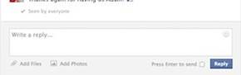
Entry Data | VALID | NO VALID
1) Inbox text field (EC) | Character >= 1
2) Inbox text field (No EC) |  | Space
3) Inbox text field (No EC) |  | Blank
4) Inbox text field (No EC) |  | Sticker
5) Inbox text field |  | Check box = enable
6) Inbox text field | Attachment charge successfully

TEST CASES
TITLE: | Verify the text field must have 1 character at less
DESCRIPTION | The button “Reply” is enable to send a message when the text field have 1 character at less
STEPS | - Put the course on the text field  - Write something  - Click on button enable “Reply”  - View the message was sent on the conversation box
EXPECTED RESULT | Button “Reply” enable to send // already reviewed on classes

NOTE: instead of using “permit” is better to use “allow”
TITLE: | Verify doesn’t permit send the message only with spaces  As described in classes, first let’s focus on what we want to test
DESCRIPTION | The button “Reply” is disable to send a message when the text field have one or more spaces
STEPS | - Put the course on the text field  - Write space  - Click on button disable “Reply”  - View the message wasn’t sent on the conversation box
EXPECTED RESULT | Button “Reply” disable to send

TITLE: | Verify doesn’t permit send the message in blank  As described in classes, first let’s focus on what we want to test
DESCRIPTION | The button “Reply” is disable to send a message when the text field is in blank
STEPS | - Put the course on the text field  - Click on button disable “Reply”  - View wasn’t sent anything on the conversation box
EXPECTED RESULT | Button “Reply” disable to send

TITLE: | Verify the sticker selected was sent  As described in classes, first let’s focus on what we want to test
DESCRIPTION | When the sticker is selected, automatically It’s send to conversation box
STEPS | - In northeast of the text field press the happy face  - Press an sticker  - View the sticker was sent on the conversation box
EXPECTED RESULT | The sticker shown into the conversation box

TITLE: | Verify the button “Reply” doesn’t shown when checkbox “Enter” is enable  As described in classes, first let’s focus on what we want to test
DESCRIPTION | When the check box “Enter” is select, the button “Reply” doesn’t shown, and the message could be send press Intro
STEPS | - Next the button “Reply” check the checkbox “Enter”  - View the button “Reply” now is disable  - Write something on text field  - Press “Intro” on the keyboard  - View the message was sent on the conversation box
EXPECTED RESULT | Button “Reply” disappear

TITLE: | Verify send attachment
DESCRIPTION | When the attachment load successfully on the text field, the button “Reply” is enable to send it
STEPS | - On the bottom of text field select the option for attachment  - Select a file  - Wait to file load, the button “Reply” is disable  - The file finish load, the button “Reply” is enable  - Press the button “Reply”  - View the attachment was sent on the conversation box
EXPECTED RESULT | Attachment load successfully and button “Reply” enable to send

Brayan/Jhasmany

I like the way you wrote your test cases, there are minor changes that I am suggesting you.

If there are any questions please let me know
Veronica

TEST CASES PRACTICE
Post on your Facebook Wall with a desktop browser. 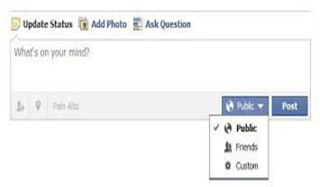
TITLE: | Verify that user enter at least one alphanumeric character.
DESCRIPTION: | Every time that user enters at least one alphanumeric character, the post button is enabled.
STEPS: | 1. - Previously, starts a session on Facebook.  2. - Go to the area of post block. Go to Post Area  3.-Make a click on text field of the post block. //block means “bloqueado” maybe you can use “Click on post text field”  4.-Enter at least one alphanumeric character.
EXPECTED RESULTS: | Post button enabled :  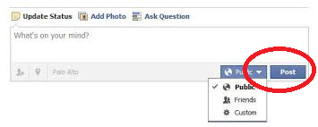  The “button post” which is marked with red on the picture.

TITLE: | Check Verify that public is selected as the default value the default select button is public.
DESCRIPTION: | Every time that user accessed to post area block, the select button is selected by default as public.
STEPS: | 1. - Previously, starts a session on Facebook.  2. - Go to the area of post area block.  3. Verify that there is a drop down list and its default value is “Public”  3.-Check that select button is selected by default as public.
EXPECTED RESULTS: | The button selected by default.  The value selected by default is PUBLIC  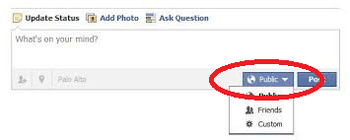  The “select button” which is marked with red on the picture.

TITLE: | Verify that select button can deploy a list with options.  Verify that the data into the “public” combo box
DESCRIPTION: | Every time that user clicks ed on the select combo box/drop down list button, a list is this deployed with three options: Public, Friends and Custom.
STEPS: | 1. - Previously, starts a session on Facebook.  2. - Go to the area of post block.  3.-Click on select button.  4. - Check that a list is deployed. //update your steps with description’s data
EXPECTED RESULTS: | Select Button displayed with three options: Public, Friends and Custom.  //update your ER with description’s data  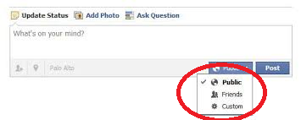

TITLE: | Verify that clicking on the post button, the entered text is published.
DESCRIPTION: | Every time that user clicks the button , the text is displayed on the wall of publications.
STEPS: | 1. - Previously, starts a session on Facebook.  2. - Go to the area of post block.  3.-Make a click on text field of the post block.  4.-Enter at least one alphanumeric character.  5.-Click on the post button.  6. - Check that the text is published on the wall of publications. //update with observations mentioned above
EXPECTED RESULTS: | A text posted on the block.  The text entered on step XX should be displayed as posted  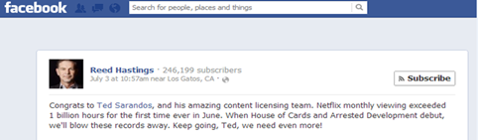

TITLE: | Verify that the published texts have a recent order.
DESCRIPTION: | Every time that user posts a text on the wall, should be displayed in the order of most recent to least recent.
STEPS: | 1. - Previously, starts a session on Facebook.  2. - Go to the area of post block.  3.-Make a click on text field of the post block.  4.-Enter at least one alphanumeric character.  5.-Click on the post button.  6. Return at 2 step only one time and go to 7 step.  7. Go to the wall of publications.  8.-Verify that post is displayed in the order of most recent to least recent.
EXPECTED RESULTS: | Text published by the most recent the least recent.  